Spreadsheet Assignment

- Framing the Problem

Monetary Authority of Singapore is concern about people with little or no knowledge in investment risk. There are many cases where personal banker wanted to sell the financial product to their customer, they may neglected of each individual risk level or may selling it according to their own interest rather than client interest. Risk assessment is needed to enforce in order to protect the customer from exposing an unwanted risk. Thus, they would like to implement a risk assessment policy and to recommend them the appropriate investment given by each individual risk level.

In compliance with the policy, our regional manager of the sale department team of the Citibank have stressed that creation of an information system to as assess clients and at the same time recommend the appropriate investment to the client. It would be better to advice client on the investment expected return.

Due to the lack of a proper system and as a personal banker of Citibank, I have come up an information system for the sales department team as well as personal banker to assist them in recommending the investment product to our client.

- The Objective

The design and implementation are based on the objective of the system. It is important to know the objective and always check whether the objectives are met during design and implementation of the system.

The system should help the user to perform the following tasks:

- Enable the user to conduct first level check on client whether the client are willingly to take risk.
- Enable the user to conduct second level check on client whether the client are able to take risk.
- Enable the user to recommend the investment based on the client risk profile.
- Enable the user to advice on the expected return based on the client investment.
- Help user to have a better view on all the investment return.
- Help user to analyse the result when situation arises.

- Brief Description of the Information Systems

Spreadsheet Design

Five spreadsheets will be design and implemented for the system:

1. Customer Profile It provides information of the customer when you enter the unique customer ID code number.
2. Customer Data Customer risks are being assessed by conduct first level check and second level check.
3. Decision Table Tables are setup to provide score based on bank internal rating
4. Pivot Chart It provides a better view for the user on all investment return and be able to make comparison between the investment products.
5. Scenario Summary User can advise his client based on what if analysis when situation arise.

- Description of All Parameters Used in the System

There are two level of check to determine the risk level of the individual. The 1st level check is the check of whether client is wiliness to take risk. It will return as “Risk lover” if the input on the column is a “Yes” in the “Client Willingness” to take risk. However, it will return as risk adverse when the input is a “No” in the “Client Willingness” to take risk. The recommendation of the risk adverse individual is the risk free government bond.

The second level of check is the check the ability of the individual that are willingness to take risk. The ability test is the calculated based on the client’s age, monthly salary and the number of dependencies. The score range for each of the factor is 1 to 3 except for the age which is 0 to 3.The Total score is the sum of age, monthly salary and number of dependencies. The maximum score is 9 and the minimum score is 2.

The score of 3 and below is “Unable to take risk” and the recommendation to this individual is Government Bond. The score of 4 to 6 is “Risk lover” but low ability and the recommendation is Corporate AAA Bond Fund. Finally, the score of 7 and above is the individual that are able to take the risk which is the suitable to invest in the Mutual Fund.

The System Flow Chart

1st level check: Willingness check

Risk Lover Risk Lover

Risk adverse

2nd level check: Ability check

Based on Decision table that have score attach to age, salary, dependencies

Score 4 to 7
Score 3 and below
Score 7 and above

Risk lover but low ability

Unable to take risk

Able to take the risk

Government Bond

Corporate AAA Bond Fund

Mutual Fund

- Key Formulas & Features Used

- Sort and Filter

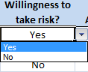
The sort and filter feature which help the users to select the appropriate answer to the question of willingness to take risk

- Create table and name manager

There are six table created. There are five decision table and 1 customer profile table .The Five decision table (Age table, Salary table, Dependency table, Total score table, expected return table ) have created to assign value or score to the other worksheet are shown in Fig.1A and customer profile table are shown in Fig1B.

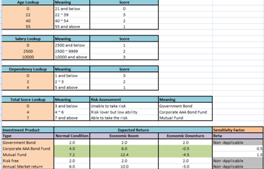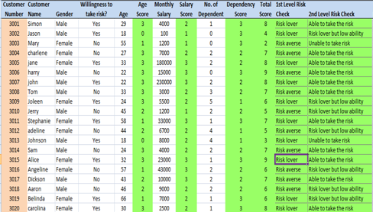
Fig. 1A Fig.1B

- Tables that I have created using Name Manager in Formulas tab.

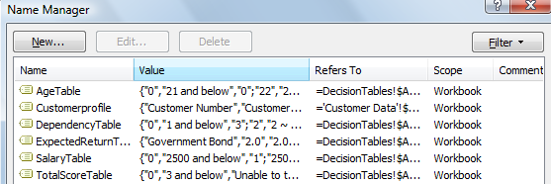

- Vlookup

- From the customer data spreadsheet, the customer profile table was created.

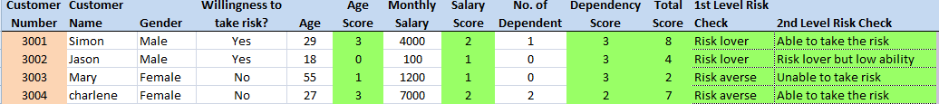

- The customer profile spreadsheet, there is an Vlookup function so as to quickly retrieve customer information by entering the input of the customer ID

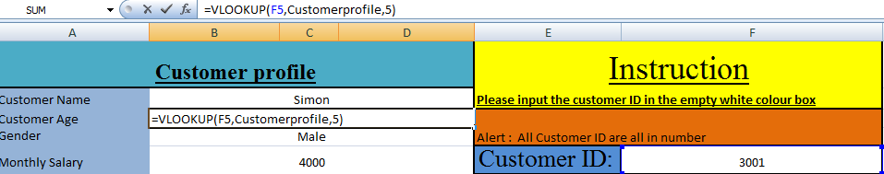
- The First Level Check

A “Yes” input in the column D will translate a Risk lover and a “No” input in the input column D will translate a Risk averse.

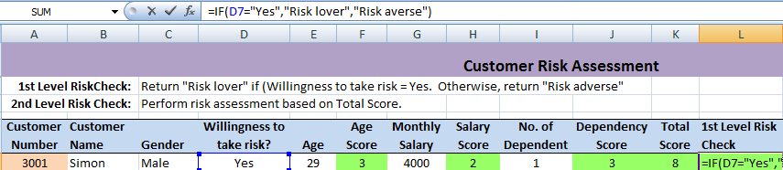

- The Second Level Check

- The Connectivity of Age ,Salary and dependency score to their respective table
- =IF (ISBLANK (E7),"", VLOOKUP (E7, AgeTable, 3, TRUE)) is at the column F, under the age score. It looks up at the score given by the age table.
- =IF (ISBLANK (G7),"", VLOOKUP (G7, SalaryTable, 3, TRUE)) is at the column H, under the salary score. It looks up at the score given by the Salary Table.
- =IF (ISBLANK (I7),"", VLOOKUP (I7, Dependency Table, 3, TRUE)) is at the column H, under the Dependency score. It looks up at the score given by the Dependency Table.

- The Total score is equal the sum of all factors score

The total score are dependent on the age score, salary score and the dependency score. The Total score show the sum of the three factors as below:

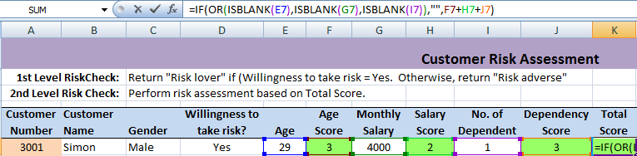

- A second level check is conducted base on total score and look up for the respective table.
The total score will look up the total score table and return the description base on the total score.

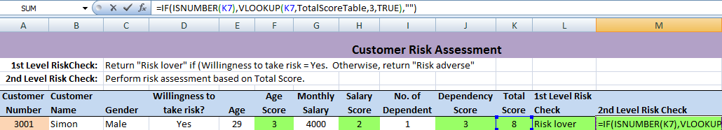

- Investment Recommendation are based on second level check

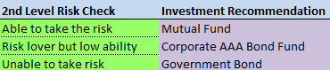
The investment recommendation will show the investment products based on the second level check
on the customer.
- Data Validation

- Input message Before enter the data input

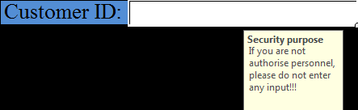

The input message of title of message of “Security purpose” and “If you are not authorise personnel, please do not enter any input!!!” will appear when you are select the input box for customer ID.

- Warning message to prompt the user when user incorrectly input

It is known as the input validation where Restrictions are made to alert the user to be careful to input data correctly in order to search for client profile.

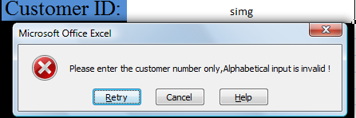

- Formula

The expect return of the investment is based on Capital asset pricing model which given the formula of ERi = RF + Bi ((ERm) – (RF)), Where ERi is the represent the expected return of the financial investment product, RF is the Risk free rate which also equivalent to the expected return of the Government bond, ERM is the expected return of the annual return of the standard and poor.

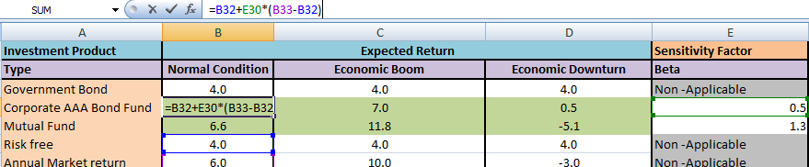

- Pivot Chart

The Y axis is measure of expected return. The X axis is representing the risk free, market and the investment product. Sum of factor are factoring in the respective of market condition, economic boom and as well as economic downturn. It is easier to compare the expected return of all investment and as well as market return at a glance.

- Interrogation of the Model

The user can run the “What-If” analysis to help him to advise his client, if the risk free rate changing, what will happen to the expected return of the investment product.

So it prompt you with question like, what if Government will to change the interest rate, will the expected return be changed?

- Add a scenario where government change interest rate

The scenario where government will to change the interest rate is added

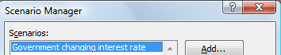

- The changing cells reflect the changing value of interest rate

- The scenario summary

The scenario summary shows what will it happen when the government will to change the interest rate.

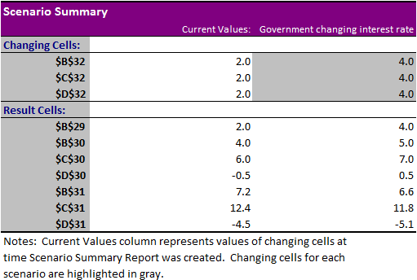

- Conclusion

There are many financial products in the real world. Some of the financial product is complex and specially design for specified investors. This model has regretted to include such complex and the variety of financial product for recommendation.

At the start of this project assignment, I did research about investment risk and return to provide useful recommendation. Initially, I have tried using a lot of variable but later which I have found out that it is too confusing. Besides consider the number of variable to be added on in risk assessment, the design and implementing the system is a challenge to me. There is a lot of checking need to be done especially when using the Vlookup function. An error input or omission of input will cause Vlookup unable to “lookup” or link to reference cell.

There are limitations in this model but overall I would say that the model can provide basic analyses for the user and able to recommend the investment products based on their risk level.

